THE UNIVERSITY OF CHENAB, GUJRAT

Department of Computer Science
FINAL YEAR PROJECT PROPOSAL
Beaker Breakers Studio
AI-Powered Gamified Virtual Chemistry Laboratory Portal with Augmented Reality for Secondary Schools
BSCS/SE
Session: 2023–2027
Project Supervisor: Ms. Mehk Fatima
Co Supervisor: Dr. Waqas Ahmed
Submitted By
Rabail Mehboob BSCS012313003
Syed Mohsin Abbas BSSE012313006

The University of Chenab, Gujrat

Approval
Thesis Supervisor Comments:

FYP Coordinator Comments:

Project Coordinator Project Supervisor

Contents
Project Title 4
Beaker Breaker Studio: 4
1. Introduction 4
1.1 Statement of the Problem 4
1.2 Scope of the Project 4
1.3 Nature of End Product 5
1.4 Project Goals & Objective 5
2 High-Level System Components 6
3 List of Optional Functional Units 7
4 Application Architecture 8
5 Gantt Chart 8
6 Hardware and Software Specification 10
6.1 Hardware Requirements (Development) 10
6.2 Software Requirements (Development) 10
6.3 Minimum End-User Device Requirements 11
7 Tools and Technologies Used 12

Table 1Features Comparison 8
Table 2 High Level System Components 10
Table 3 Application Architectures 11
Table 4 Gantt Chart 13
Table 5 Hardware and Software Specifications 13
Table 6 Software Requirements 14
Table 7 Minimum End-User Device Requirements 15
Table 8 Tools and Technologies Used 16

Figure 1 Architecture Diagram 14
Figure 2 System Flowchart 20
Figure 3 Class Diagram 21
Figure 4 ERD 22
Figure 5 Sequence Diagram 23
Figure 6 Notification Module Sequence Diagram 24
Figure 7 Dashboard Module Sequence Diagram 25
Figure 8 AI Readiness Prediction Diagram 25
Figure 9 Gamification Module Sequence Diagram 26
Figure 10 AI Guidance Module Sequence Diagram 27
Figure 11 AR Experiment Module Sequence Diagram 28
Figure 12 Safety Certification Module Sequence Diagram 29
Figure 13 Task Assignment Module Sequence Diagram 30
Figure 14 Authentication Module Sequence Diagram 31

Project Title
Beaker Breakers Studio: An AI-Powered Gamified Virtual Chemistry Laboratory Portal with Augmented Reality for Secondary Schools

Introduction
Chemistry education at the secondary school level relies heavily on practical laboratory work, but most schools worldwide fail to provide adequate laboratory experiences due to safety risks, limited resources, high chemical costs, and insufficient safety training. The advancement of artificial intelligence and augmented reality has created new opportunities to address these challenges through technology-driven solutions. This project proposes Beaker Breakers Studio, an AI-powered gamified virtual chemistry laboratory portal for secondary schools, integrating AR story telling mode, game mode, AI guidance, and safety certification into a single institutional platform accessible to schools, teachers, and students regardless of their physical resources or location.

Statement of the Problem
Most secondary schools fail to provide adequate practical chemistry education due to safety risks that restrict laboratory access for junior students, high costs and unavailability of chemical reagents, legal prohibition of hazardous substances, limited laboratory resources causing passive observation rather than active experimentation, and insufficient safety training with no formal competency verification. Existing virtual laboratory platforms such as Labster, PhET, PraxiLabs, and OLabs partially address these issues but remain inadequate due to their lack of AI-driven assessment, safety certification, gamification, and dedicated school management capabilities.

Scope of the Project
This project involves the development of a web-based virtual chemistry laboratory portal for secondary schools with role-based access for students, teachers, and administrators. The system will provide curriculum-aligned AR story telling mode safety certification, performance evaluation and controlled gamification.
The scope is limited strictly to virtual chemistry experimentation at the secondary level and excludes physical laboratory infrastructure, university-level practicals, third-party system integration and expansion beyond chemistry. All development will remain within these defined boundaries to ensure completion within the nine-month timeline.

Nature of End Product
The completed Beaker Breakers Studio system will comprise the following deliverable components:
- A web application (React.js + Next.js) providing the primary student and teacher interface, accessible from any modern browser on desktop or laptop.
- A cross-platform mobile application (Flutter + Dart) for Android and iOS, supporting both Game Mode and AR Mode.
- A Laravel (PHP) RESTful API backend serving both the web and mobile clients, with MySQL database storage and Redis caching.
- A school administrator panel built on Filament providing institution-level management of student records, class assignments, experiment libraries, and safety certificates.
- A digital Safety Certificate, automatically generated and issued upon successful completion of all four safety training tiers, stored in the student's profile and available for teacher review.
- AI readiness reports generated on demand by teachers, powered by the Gemini API, providing a structured assessment of each student's readiness for real laboratory access.
- An AR experiment experience accessible through the mobile application using the device's camera and motion sensors, featuring a 3D avatar AI assistant that appears in the student's real-world environment.

Project Goals & Objective
The following objectives define the core deliverables of Beaker Breakers Studio:
- Develop an AI guidance system using API-based models that teaches students step by step, detects errors in real time, and gives instant corrective feedback.
- Build a four-tier interactive safety training module that certifies students before they access any experiment.
- Create an AI-driven readiness prediction system that analyses student performance history and tells teachers whether a student is ready for a real laboratory.
- Design a gamification engine with points, badges, rank levels, leaderboards, and challenge missions to keep students motivated and engaged.
- Develop an Augmented Reality mode that allows students to understand virtual chemistry experiments overlaid on their real physical environment using any ordinary smartphone camera without requiring expensive hardware.
- Make the platform accessible on all devices including computers, tablets, and smartphones.

Feature comparison — Beaker Breakers Studio vs existing platforms
Feature | Labster | PhET | PraxiLabs | OLabs | Mobile Games | Beaker Breakers Studio
Target level | University | K-12 + Uni | College | Class 9–12 | Personal use | Secondary school
Dedicated school portal per institution | ✕ | ✕ | ~ | ~ | ✕ | ✓
Game Mode (levels + progression) | ✕ | ✕ | ✕ | ✕ | ~ | ✓
AR Mode (smartphone camera) | ✕ | ✕ | ✕ | ✕ | ✕ | ✓
3D avatar AI assistant | ✕ | ✕ | ~ (Oxi bot) | ✕ | ✕ | ✓
Real-time AI guidance (LLM) | ✕ | ✕ | ✕ | ✕ | ✕ | ✓
6-dimension performance scoring | ✕ | ✕ | ✕ | ✕ | ✕ | ✓
AI readiness prediction for real lab | ✕ | ✕ | ✕ | ✕ | ✕ | ✓
4-tier safety certification | ✕ | ✕ | ✕ | ✕ | ✕ | ✓
Digital safety certificate | ✕ | ✕ | ✕ | ✕ | ✕ | ✓
Gamification (XP, badges, ranks) | ~ | ✕ | ~ | ✕ | ~ | ✓
Class leaderboard | ✕ | ✕ | ✕ | ✕ | ✕ | ✓
Teacher live dashboard | ✓ | ✕ | ✓ | ~ | ✕ | ✓
Mobile app (Android + iOS) | ~ | ~ | ✓ | ✓ | ✓ | ✓
Free / open access | ✕ paid | ✓ free | ~ freemium | ✓ free | ~ | Institutional
Chemistry-only focus | ✕ STEM broad | ✕ multi-sci | ✕ bio+phys too | ✕ multi-sci | ~ | ✓ deep focus
No special hardware required | ✓ | ✓ | ✓ | ✓ | ✓ | ✓
No. of experiments (chemistry) | 300+ | 30+ | 210+ | 46 | Varies | 30+ (v1)
Table 1Features Comparison

High-Level System Components
The system is organized into the following major functional modules:
Module | Description
School Portal | Dedicated institutional portal with multi-role login, student enrolment, class management, and school-specific branding.
Game Mode | Progressive level-based chemistry challenges. Students advance through increasingly complex experiment scenarios, earning XP and badges. No 3D rendering required — designed for any device.
AR Mode | Augmented reality experiment interface using the smartphone camera. A 3D avatar AI assistant appears in the student's real environment and provides step-by-step spoken and visual guidance.
Avatar AI Assistant | 3D character that appears in AR Mode. Narrates steps, warns of errors, celebrates correct actions, and answers student questions. Powered by GPT-4o online or Phi-3 Mini offline.
Safety Certification | Four-tier interactive safety training programme. Each tier must be passed at 80%+ before the next unlocks. Digital certificate issued on full completion.
AI Scoring Engine | Evaluates student performance across six dimensions in real time: Procedural Accuracy, Safety Compliance, Reagent Management, Time Efficiency, Conceptual Understanding, and Error Recovery.
AI Readiness Predictor | GPT-4o powered analysis of cumulative student performance data. Generates structured readiness reports classifying students as Not Ready, Approaching Readiness, or Ready.
Gamification Engine | XP system, 60+ achievement badges, 8 rank levels, class and school leaderboards, weekly missions, and streak tracking.
Teacher Dashboard | Live class monitoring, per-student performance analytics, safety certificate status, AI readiness report generation, and manual attendance controls.
Admin Panel | School-level management of student records, teacher accounts, experiment library configuration, and system settings via Filament.
Notification System | Firebase Cloud Messaging for push notifications to mobile. SendGrid for email. Teachers can broadcast experiment reminders and safety alerts.
Table 2 High Level System Components

List of Optional Functional Units
The following features are planned as optional or Phase 2 functional units that enhance the core system but are not part of the minimum viable product:
- Collaborative virtual lab sessions where two or more students join a shared experiment environment in real time.
- Parent portal providing read-only access to student safety certification status, experiment scores, and rank progress.
- Custom experiment builders allow teachers to design virtual experiments using a no-code authoring tool.
- Multi-language interface support for Urdu, Arabic, Hindi, French, and Spanish.
- Experiment replay feature allowing students to review completed sessions with AI commentary.
- Seasonal and event-based limited-edition avatar accessories and challenge missions.
- AI-generated personalized revision experiment sets for national examination preparation.
- Certificate of Excellence generation in PDF format for top-performing students.

Application Architecture
Beaker Breakers Studio follows a three-tier client-server architecture deployed on cloud infrastructure. The presentation tier consists of a React.js web portal and a Flutter mobile application. The application tier is a Laravel (PHP) backend serving REST API endpoints for both web and mobile clients, supported by Laravel Sanctum for authentication, Laravel Echo with Pusher for real-time notifications, and Laravel Queues for background job processing. The data tier consists of a MySQL relational database for all users, school, and performance records, and a Redis in-memory store for caching and real-time leaderboard computation.
AI capabilities are integrated at the application tier through API calls to the Gemini API for experiment guidance, performance scoring, and readiness prediction, and to the ElevenLabs API for voice narration. The AR module operates at the device level using ARCore (Android) and ARKit (iOS) accessed through the Flutter AR Plugin. Static assets including three-dimensional models, textures, and educational media are stored on AWS S3 and delivered globally through Cloudflare CDN to minimize loading times for students in diverse geographic locations.
Tier | Components | Technology
Presentation Tier | Web Portal, Mobile Application | React.js + Next.js, Flutter
Application Tier | REST API Server, Authentication, Real-Time, Queues, AI Integration | Laravel (PHP), Sanctum, Echo+Pusher, Gemini API, ElevenLabs API
Data Tier | Relational Database, Cache, File Storage, CDN | MySQL, Redis, AWS S3, Cloudflare CDN
Device Layer | 3D Rendering, AR Mode, | Three.js, ARCore/ARKit
Table 3 Application Architectures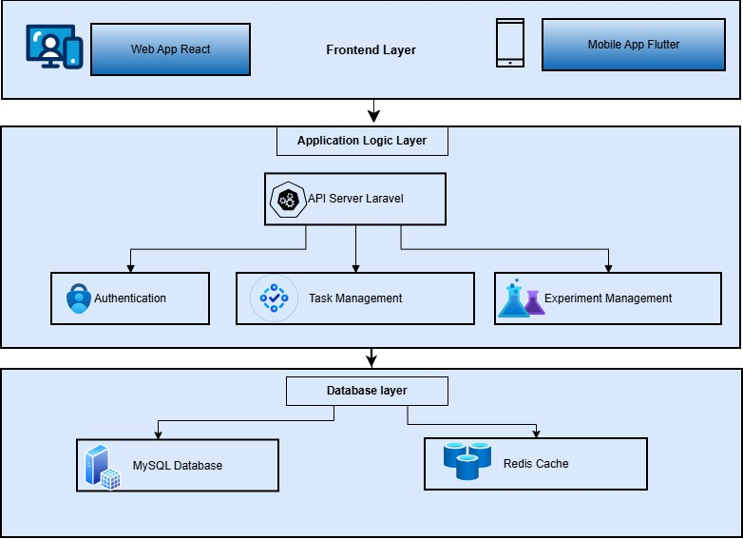
Figure 1 Architecture Diagram

Gantt Chart
The following Gantt chart outlines the nine-month development timeline for Beaker Breakers Studio across three structured phases:
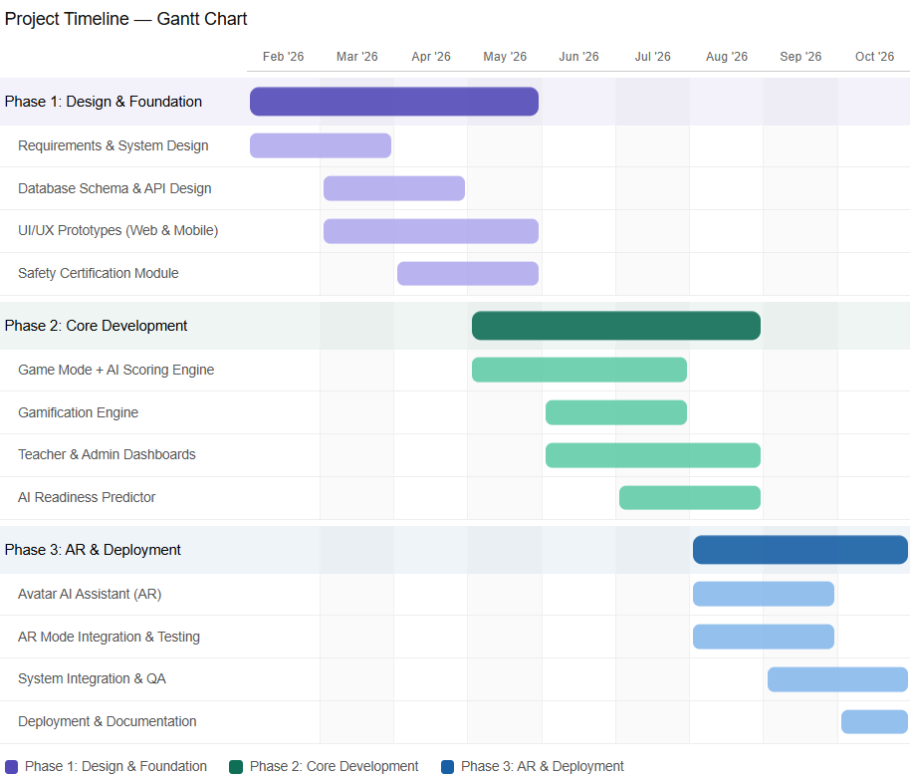 Table 4 Gantt Chart

Hardware and Software Specification

Hardware Requirements (Development)

Component | Minimum | Recommended
Development Machine | Intel Core i5, 8GB RAM, 256GB SSD | Intel Core i7/i9, 16GB RAM, 512GB SSD
Web Server (Cloud) | 2 vCPU, 4GB RAM, 50GB storage | 4 vCPU, 8GB RAM, 100GB SSD (AWS EC2)
Mobile Device (Game Mode) | Android 6.0 / iOS 11, 2GB RAM | Android 8.0+ / iOS 13+, 4GB RAM
Mobile Device (AR Mode) | Android 7.0 ARCore / iOS 11 ARKit, gyroscope, camera | Android 9.0+ / iOS 14+, 4GB RAM, good camera
Network | 3G mobile / 1 Mbps broadband | 4G/LTE or Wi-Fi for optimal AI response time
Table 5 Hardware and Software Specifications

Software Requirements (Development)
Software | Version | Purpose
Laravel (PHP) | 11.x | REST API backend and admin panel
React.js + Next.js | 18.x / 14.x | Web frontend with SSR
Flutter + Dart | 3.x | Cross-platform mobile app (Android + iOS)
MySQL | 8.0+ | Primary relational database
Redis | 7.x | Caching, sessions, queues, leaderboards
Node.js | 20 LTS | Build tooling and SSR server
ARCore / ARKit | Latest | Augmented reality surface detection
Gemini API | Latest | Online AI guidance and readiness prediction
ElevenLabs API | Latest | Avatar voice synthesis (online)
Cloudinary | API v2 | Media asset storage and delivery
AWS S3 + Cloudflare CDN | Latest | Document storage and static asset delivery
Firebase Cloud Messaging | Latest | Push notifications to mobile devices
SendGrid | v3 API | Transactional email delivery
Table 6 Software Requirements

Minimum End-User Device Requirements
Requirement | Minimum Specification
Web Browser | Chrome 90+, Firefox 88+, Safari 14+, Edge 90+ with WebGL support enabled
Device RAM | 4 GB RAM for 3D lab; 3 GB RAM for standard portal access
Internet Speed | Minimum 2 Mbps for standard mode; 5 Mbps recommended for AR mode
Mobile OS (AR) | Android 7.0+ with ARCore support, or iOS 11+ with ARKit support
Mobile Camera | Rear-facing camera required for AR experiment mode
Table 7 Minimum End-User Device Requirements

Tools and Technologies Used
Technology | Rationale
Laravel (PHP) | Chosen over Node.js/Django because PHP is natively supported on virtually all shared hosting and VPS providers in Pakistan, reducing deployment cost. Laravel's ecosystem — Sanctum, Filament, Queues, Events — provides all required backend features out of the box. The GPT-4o API removes the need for Python for AI tasks.
Flutter (Dart) | Single codebase for Android and iOS eliminates the cost and complexity of maintaining two separate native applications. Flutter's mature ARCore/ARKit plugin ecosystem makes AR Mode feasible within the project timeline. Flutter AI Toolkit provides first-class support for on-device AI model inference.
React.js + Next.js | Server-side rendering improves page load performance and SEO. The large React ecosystem provides ready-made component libraries that accelerate development. Next.js API routes allow lightweight backend functionality where needed.
ARCore + ARKit | The only cross-platform AR frameworks with proven production quality for mobile. Both work on standard mid-range smartphones without specialist hardware, making AR Mode accessible to the target student demographic.
Gemini API | State-of-the-art language model providing natural language understanding for avatar question answering, readiness report generation, and contextual error explanations. API-based integration removes the need to train or host a custom model.
MySQL + Redis | MySQL provides robust ACID-compliant relational storage for all core data. Redis provides sub-millisecond caching for leaderboard data, session tokens, and API responses, which would otherwise create database bottlenecks under concurrent load.
ElevenLabs API | Produces the most natural-sounding synthesised speech available via API, critical for the avatar AI assistant's voice quality. Voice quality directly impacts the perceived quality of the AR Mode experience.
Table 8 Tools and Technologies Used

System Diagrams

Flow chart
The flowchart represents the overall workflow of the system from user interaction to final output. The process begins when a user opens the application and either registers or logs in. After successful authentication, the system determines the user role (Student, Teacher, or Admin).
For students, the system enforces a safety certification check before allowing access to experiments. If not certified, the user must complete safety training and quizzes. Once certified, the student selects an experiment and performs it using AR mode.
During the experiment, user actions are continuously sent to the backend, where AI processes them and provides real-time feedback. The system tracks performance, updates scores, and applies gamification elements such as points and badges. Finally, results are stored and an AI-based readiness report is generated.
Teachers and administrators access dashboards to monitor performance, manage users, and view reports. The process concludes with notifications and data retrieval via CDN.
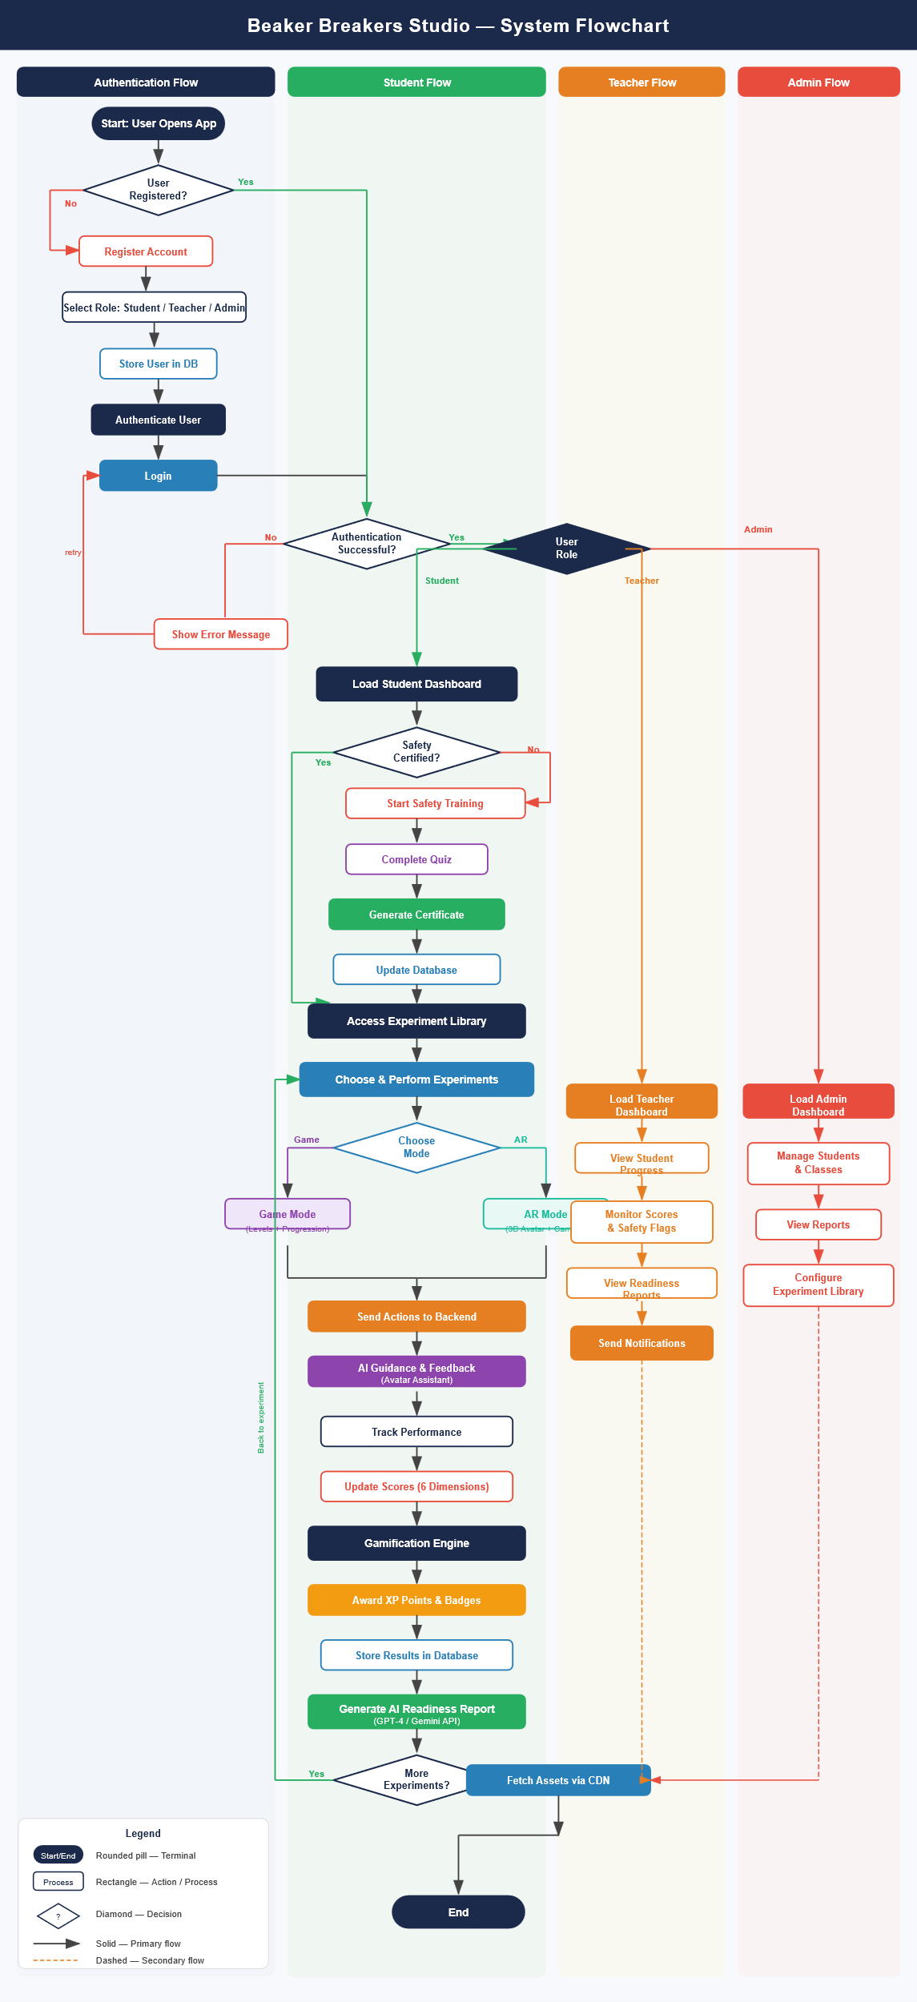
Figure 2 System Flowchart

Class Diagram
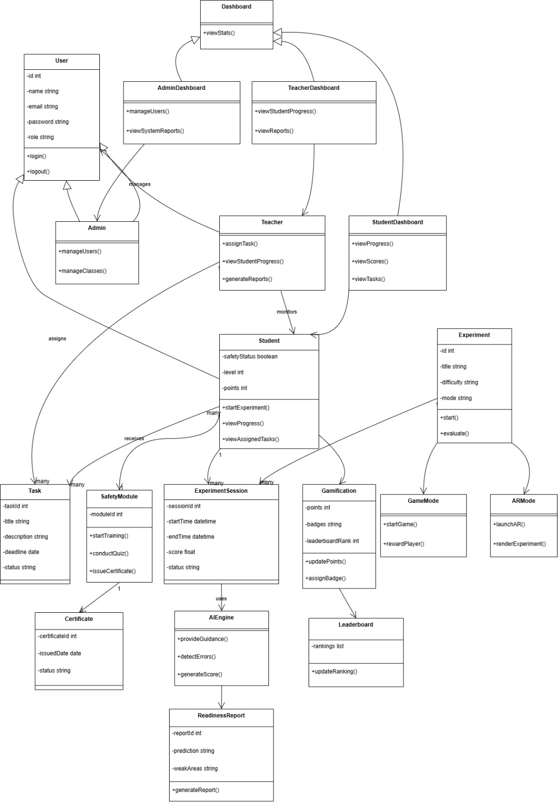
Figure 3 Class Diagram

ERD
The Entity Relationship Diagram (ERD) represents the database structure of the system, including entities, attributes, and relationships. The central entity is USER, which is associated with role-specific profiles such as STUDENT_PROFILE and TEACHER_PROFILE.
The system supports task management through TASK and TASK_ASSIGNMENT, implementing a many-to-many relationship between teachers and students.
Experiment-related data is managed through EXPERIMENT, EXPERIMENT_SESSION, and EXPERIMENT_LOG, enabling tracking of user activities and performance.
Safety and certification are handled using SAFETY_ATTEMPT and CERTIFICATE, while AI-generated insights are stored in READINESS_REPORT. Gamification is implemented through the REWARD entity.
The design follows normalization principles, ensuring minimal redundancy and efficient data management.
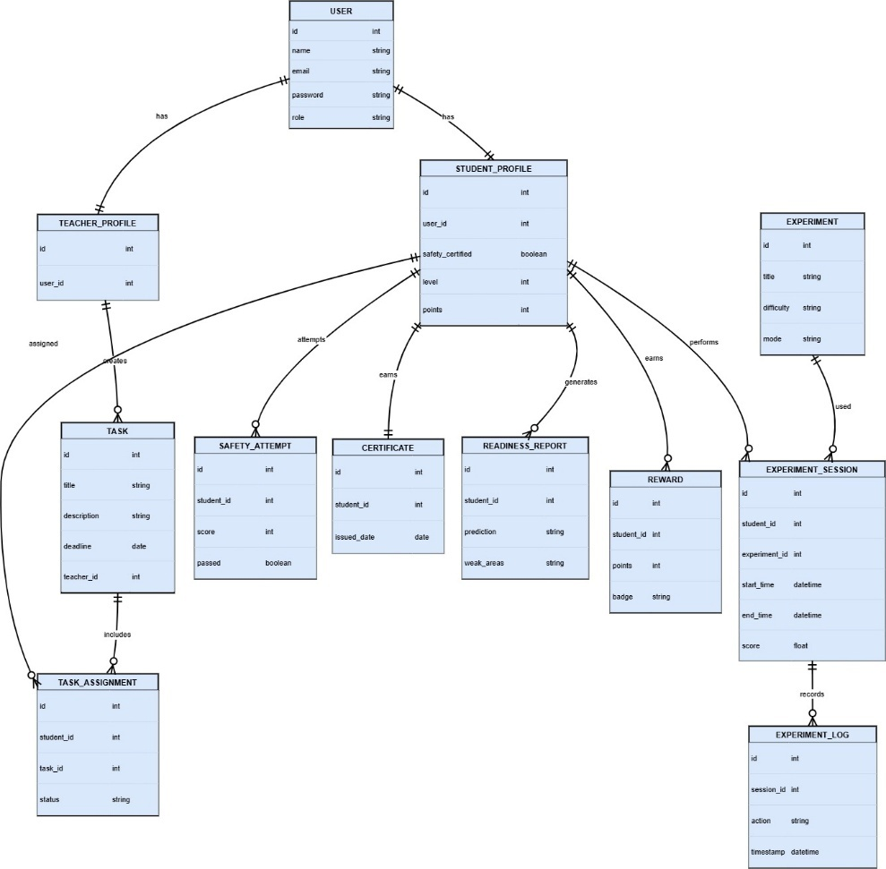
Figure 4 ERD

Sequence Diagram
The sequence diagram illustrates the interaction between system components over time. It shows how users (Student and Teacher) communicate with the client application, which then interacts with the backend API, database, AI engine, and other services.
The process starts with user authentication, followed by task assignment by the teacher. When a student initiates an experiment, the system verifies safety status before granting access.
During the experiment, a loop represents continuous interaction where user actions are sent to the backend, processed by the AI engine, and feedback is returned in real time. The system simultaneously stores progress in the database.
After completion, results are submitted and stored, and teachers can later access this data through dashboards. The diagram effectively demonstrates real-time processing, system coordination, and data flow.
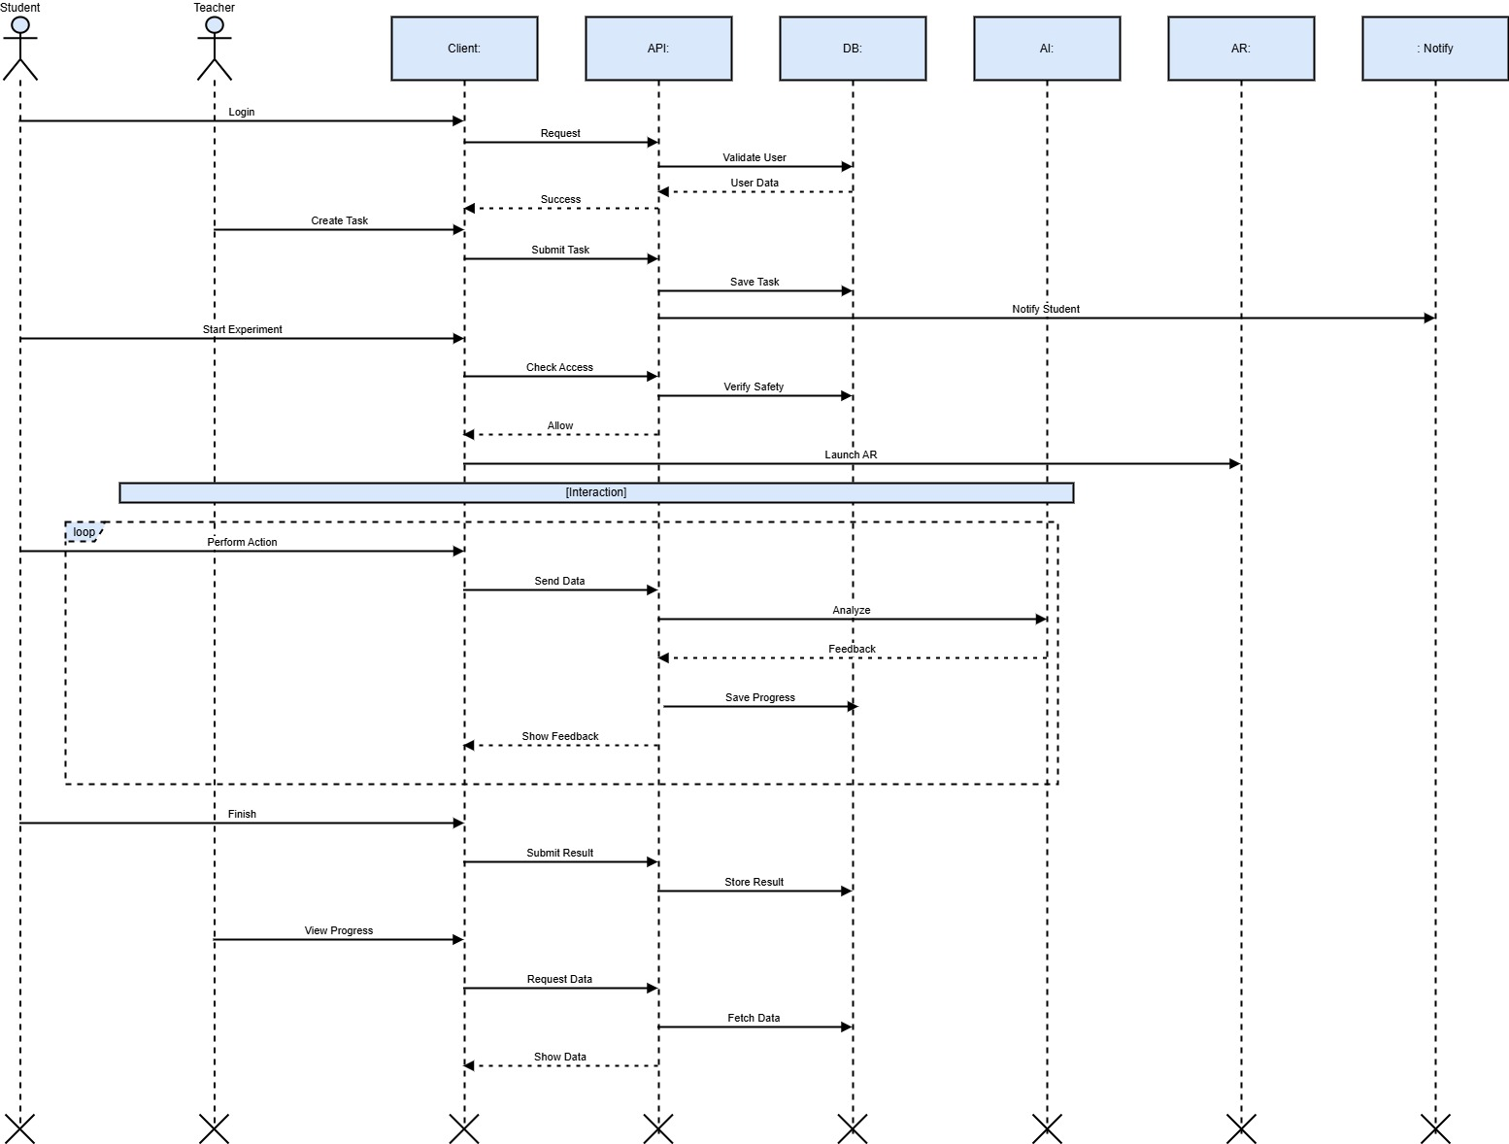
Figure 5 Sequence Diagram
The system is divided into multiple modules such as authentication, task management, safety training, experiment execution, AI processing, and gamification. Each module is represented through individual sequence diagrams to simplify understanding and maintain modularity.
This approach allows each component to be analyzed independently while maintaining overall system coherence. It improves readability, maintainability, and documentation quality.

Notification Module Sequence Diagram
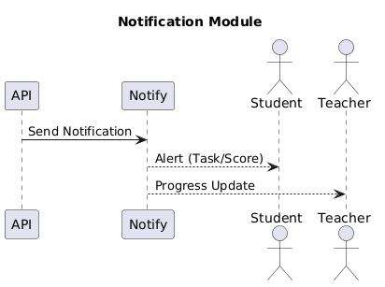
Figure 6 Notification Module Sequence Diagram

Dashboard Module Sequence Diagram

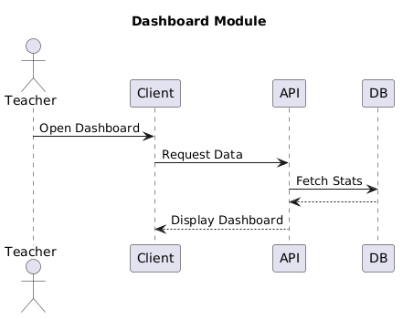
Figure 7 Dashboard Module Sequence Diagram

AI Readiness Prediction Diagram

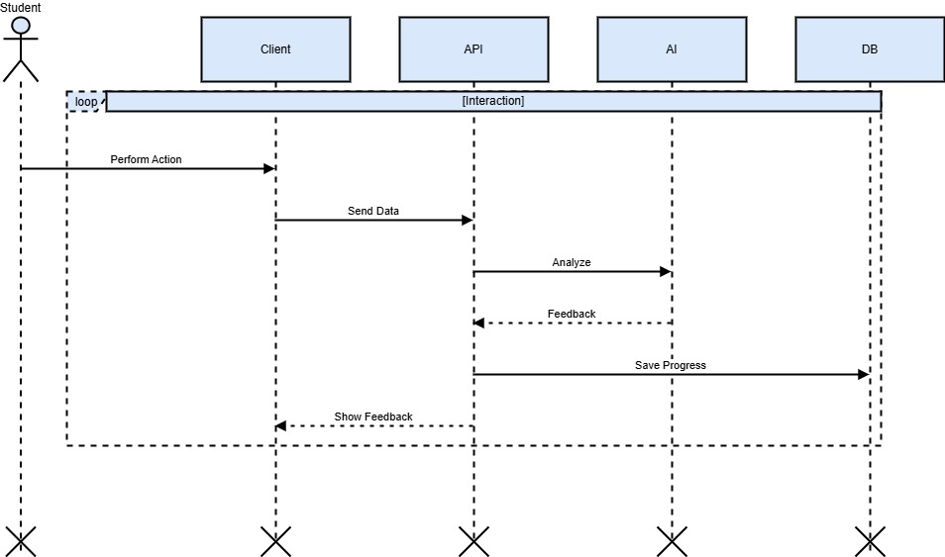
Figure 8 AI Readiness Prediction Diagram

Gamification Module Sequence Diagram
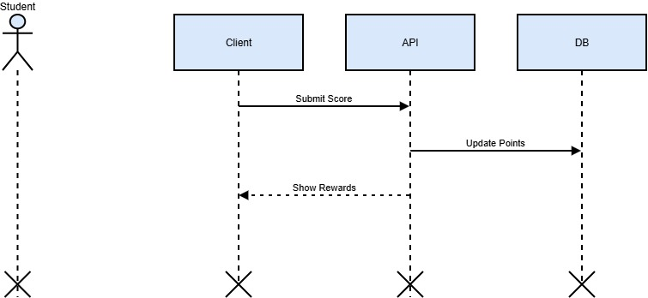
Figure 9 Gamification Module Sequence Diagram

AI Guidance Module Sequence Diagram

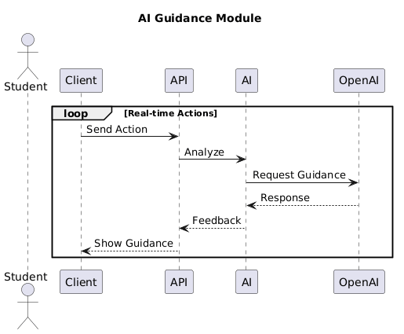
Figure 10 AI Guidance Module Sequence Diagram

AR Experiment Module Sequence Diagram

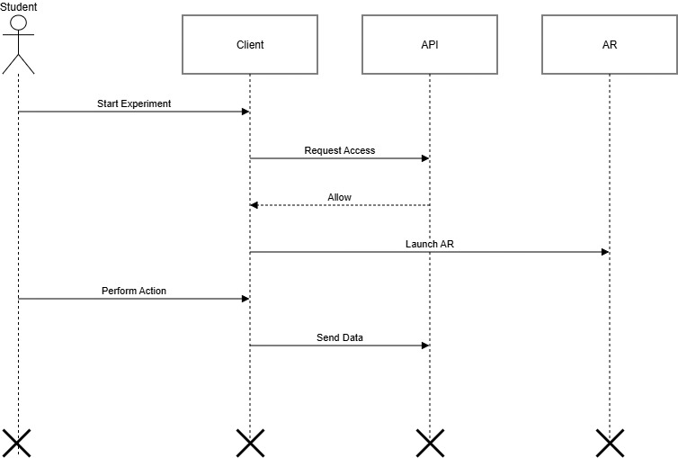
Figure 11 AR Experiment Module Sequence Diagram

Safety Certification Module Sequence Diagram
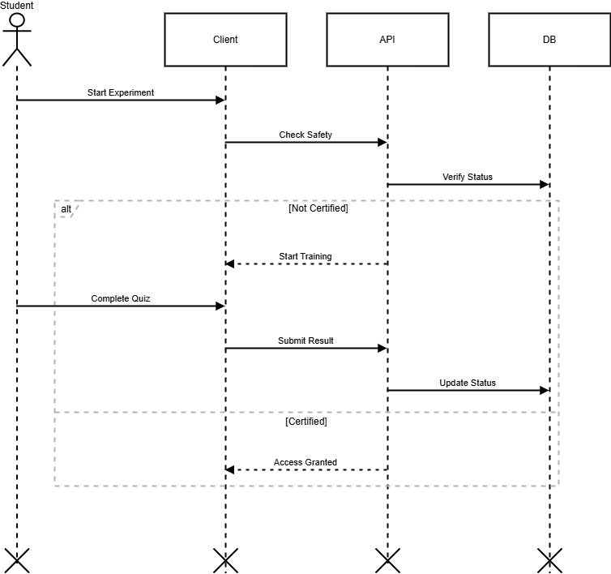
Figure 12 Safety Certification Module Sequence Diagram

Task Assignment Module Sequence Diagram
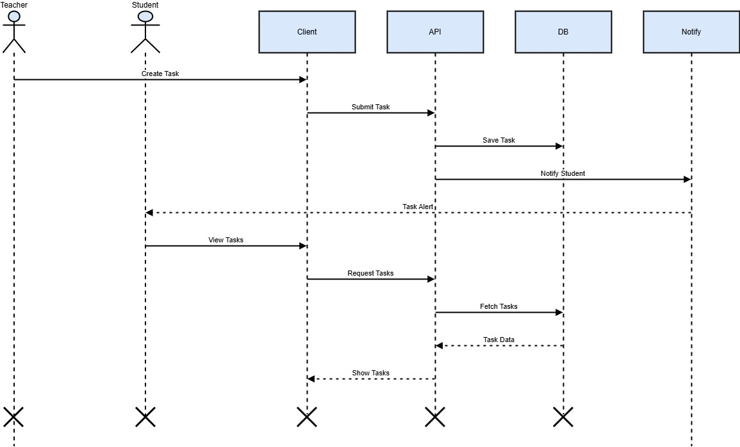
Figure 13 Task Assignment Module Sequence Diagram

Authentication Module Sequence Diagram
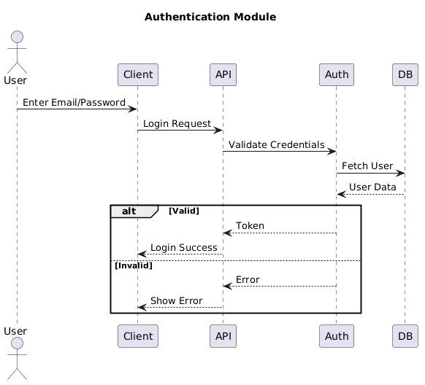
Figure 14 Authentication Module Sequence Diagram

References
- Azuma, R. T. (1997). A survey of augmented reality. Presence: Teleoperators and Virtual Environments, 6(4), 355–385. https://doi.org/10.1162/pres.1997.6.4.355
- Dalgarno, B., & Lee, M. J. W. (2010). What are the learning affordances of 3-D virtual environments? British Journal of Educational Technology, 41(1), 10–32. https://doi.org/10.1111/j.1467-8535.2009.01038.x
- Dede, C. (2009). Immersive interfaces for engagement and learning. Science, 323(5910), 66–69. https://doi.org/10.1126/science.1167311
- Google DeepMind. (2024). Gemini: A family of highly capable multimodal models. https://storage.googleapis.com/deepmind-media/gemini/gemini_1_report.pdf
- Makransky, G., & Lilleholt, L. (2018). A structural equation modelling investigation of the emotional value of immersive virtual reality in education. Educational Technology Research and Development, 66(5), 1141–1164. https://doi.org/10.1007/s11423-018-9581-2
- Merchant, Z., Goetz, E. T., Cifuentes, L., Keeney-Kennicutt, W., & Davis, T. J. (2014). Effectiveness of virtual reality-based instruction on students' learning outcomes in K-12 and higher education. Computers & Education, 70, 29–40. https://doi.org/10.1016/j.compedu.2013.07.033
- Microsoft Research. (2024). Phi-3 technical report: A highly capable language model locally on your phone. arXiv. https://arxiv.org/abs/2404.14219
- Moore, E. B., Chamberlain, J. M., Parson, R., & Perkins, K. K. (2014). PhET interactive simulations: Transformative tools for teaching chemistry. Journal of Chemical Education, 91(8), 1191–1197. https://doi.org/10.1021/ed4005084
- Nedungadi, P., Malini, P., & Raman, R. (2015). Inquiry based learning pedagogy for chemistry practical experiments using OLabs. Advances in Intelligent Informatics, 320, 633–642. https://doi.org/10.1007/978-3-319-11218-3_57
- Radianti, J., Majchrzak, T. A., Fromm, J., & Wohlgenannt, I. (2020). A systematic review of immersive virtual reality applications for higher education: Design elements, lessons learned, and research agenda. Computers & Education, 147, Article 103778. https://doi.org/10.1016/j.compedu.2019.103778
- Scherer, R., Siddiq, F., & Tondeur, J. (2019). The technology acceptance model (TAM): A meta-analytic structural equation modeling approach to explaining teachers' adoption of digital technology in education. Computers & Education, 128, 13–35. https://doi.org/10.1016/j.compedu.2018.09.009
- University of Chenab. (2024). Academic regulations for final year projects. University of Chenab Press.

